BERT Language Model for numbers and mathematical logic comprehension.

Case Study

Polina Verzun

10 July, 2020

# 

# Abstract

Many studies were conducted in attempts to interpret the reasoning behind BERT language comprehension, revealing it’s bayes regarding different topics. In this paper we examine BERT’s understanding of numbers and its ability to solve mathematical problems that contain numbers. We reveal how BERT understands the relations between numbers and how the formulation of the mathematical problem and words used in it can significantly affect BERT’s performance with such questions. Most importantly, we provide the code that can be used to conduct further experiments on this topic. All the code used for the experiments is provided [in this Google Colab notebook](https://colab.research.google.com/drive/1RS_JZ4P46BZH1Q8aiDqirhTrNYRfabXA?usp=sharing).

*Keywords:* BERT, Transformers, Bertology



# Introduction

Throughout the last 2 years since Google came out with BERT many studies on the BERT’s interpretability were conducted. Bertology is an ever growing field, with many further studies attempting to understand the reasoning behind BERT’s Language comprehension, which will help to utilize its capabilities efficiently.

This paper focuses primarily on numbers and mathematical logic comprehension with some unexpected results regarding names bayes discovered along the way. We use examples such as simple mathematical problems targeted towards 1-3 grade kids and preschoolers. We also conduct some brief experiments with mathematica logic problems for first-year students of technical faculties.

BERT was originally trained on BookCorpus andEnglish Wikipedia and for question-answering tasks that we use for our experiments fine-tuning was done with SQUAD dataset v1 and v2. BERT leverages Transformer architecture to learn contextual relations between words (or sub-words) in a text. Naturally, the question about BERT’s ability to learn mathematical logic and relation between numbers come into question. Kids at school lurch that mathematical logic and number theory differs significantly from the usual logic used to understand words and contexts.

Language Models such as BERT, however, do not have a separate mechanism to deal with numbers and mathematics, so they treat numbers as just words. This may lead to significant problems when such models are used on texts full of numerical data such as scientific papers, financial data, statistical summaries, etc.

# Methods

*Methods for exploring relations between numbers in BERT’s vocabulary.*

BERT has 881 numbers in its original vocabulary. Every number is embedded into a 768-dimensional feature-space. To visualize the relation between 768-dimensional vectors we first need to embed them into a 2-dimensional space. It can be done with the loss of distances, but with the preservation of topology within a group of words. This function helps with this visualization:

def bert_embeddings_plot(model, tokenizer, word_list):

labels = []

tokens = []

for word in word_list:

tokenized_text = tokenizer.tokenize(word)

indexed_tokens = tokenizer.convert_tokens_to_ids(tokenized_text)

segments_ids = [1] * len(tokenized_text)

tokens_tensor = torch.tensor([indexed_tokens])

segments_tensors = torch.tensor([segments_ids])

with torch.no_grad():

outputs = model(tokens_tensor, segments_tensors)

hidden_states = outputs[2]

token_vecs = hidden_states[-2][0]

word_embedding = torch.mean(token_vecs, dim=0)

tokens.append(word_embedding.tolist())

labels.append(word)

tsne_model = TSNE(perplexity=40, n_components=2, init='pca', n_iter=2500, random_state=23)

new_values = tsne_model.fit_transform(tokens)

x = []

y = []

for value in new_values:

x.append(value[0])

y.append(value[1])

plt.figure(figsize=(16, 16))

for i in range(len(x)):

plt.scatter(x[i],y[i])

plt.annotate(labels[i],

xy=(x[i], y[i]),

xytext=(5, 2),

textcoords='offset points',

ha='right',

va='bottom')

plt.show()

The model and tokenizer used are:

pretrained_bert_large = BertModel.from_pretrained("bert-large-uncased", output_hidden_states = True)

tokenizer_bert_large = BertTokenizer.from_pretrained("bert-large-uncased")

In order to make the model work with GPU:

torch.set_default_tensor_type('torch.cuda.FloatTensor')

device = torch.device("cuda:0" if torch.cuda.is_available() else "cpu")

pretrained_bert_large.to(device)

pretrained_bert_large.eval()

And here is how we extract all numbers from the vocabulary:

numbers_in_bert_vocab = [token for token in tokenizer_bert_large.vocab.keys() if token.isdigit()]

*Methods for calculating the similarity score between words and sentences.*

For this we use simple cosine similarity and BERT embeddings like this:

def bert_partwise_similarity(pairs, model, tokenizer):

for pair in pairs:

embedding_pair = {}

for sentance in pair:

marked_text = "[CLS] " + sentance + " [SEP]"

tokenized_text = tokenizer.tokenize(marked_text)

indexed_tokens = tokenizer.convert_tokens_to_ids(tokenized_text)

segments_ids = [1] * len(tokenized_text)

tokens_tensor = torch.tensor([indexed_tokens])

segments_tensors = torch.tensor([segments_ids])

with torch.no_grad():

outputs = model(tokens_tensor, segments_tensors)

hidden_states = outputs[2]

token_vecs = hidden_states[-2][0]

sentence_embedding = torch.mean(token_vecs, dim=0)

embedding_pair[sentance] = sentence_embedding

diff = 1 - cosine(embedding_pair[pair[0]].cpu(), embedding_pair[pair[1]].cpu())

print(pair, diff)

*Methods For visualizing heads of attention:*

Exploring how BERT’s attention mechanisms work is very helpful when trying to see the difference between two sentences that have just one word changed. For example: Polly has 3 apples and Polly has 100 apples. We provide multiple functions that help with visualizing heads of attention, creating gifs and different visualizations.

def fig2data(fig):

fig.canvas.draw ( )

w,h = fig.canvas.get_width_height()

buf = np.frombuffer(fig.canvas.tostring_argb(), dtype=np.uint8)

buf.shape = ( w, h,4 )

buf = np.roll ( buf, 3, axis = 2 )

return buf

def fig2img(fig):

buf = fig2data(fig)

w, h, d = buf.shape

return Image.frombytes( "RGBA", ( w ,h ), buf.tostring( ) )

def heatplot_attention(model, tokenizer, sentence, layer=None, save_gif=False):

tks_ids = tokenizer.build_inputs_with_special_tokens(tokenizer.convert_tokens_to_ids(tokenizer.tokenize(sentence)))

tks = tokenizer.convert_ids_to_tokens(tks_ids)

with torch.no_grad():

_, _, attentions = model(torch.tensor(tks_ids).unsqueeze(0))

attentions = torch.cat(attentions)

fig = plt.figure(figsize=(20, 15))

axes = []

if not layer and save_gif:

attention_layers = []

for i_layer in range(12):

for i_head in range(12):

axes.append(fig.add_subplot(3, 4, 1 + i_head))

axes[-1].set_title(f"Head {1 + i_layer}:{1 + i_head}")

layers_heatmap = sns.heatmap(attentions[i_layer, i_head].cpu(),

vmin=0, vmax=1,

yticklabels=tks, xticklabels=tks,

annot=False, ax=axes[-1],

cbar=False,

fmt='04.2f')

attention_layers.append(fig2img(layers_heatmap.get_figure()))

attention_layers[0].save('attention.gif',

save_all=True, append_images=attention_layers[1:], optimize=False, duration=500, loop=0)

else:

print(layer)

for i_head in range(12):

axes.append(fig.add_subplot(3, 4, 1 + i_head))

axes[-1].set_title(f"Head {1 + layer}:{1 + i_head}")

sns.heatmap(attentions[layer, i_head].cpu(),

vmin=0, vmax=1,

yticklabels=tks, xticklabels=tks,

annot=False, ax=axes[-1],

cbar=False,

fmt='04.2f')

def bipartite_attention(model, tokenizer, sentence, layer):

tks_ids = tokenizer.build_inputs_with_special_tokens(tokenizer.convert_tokens_to_ids(tokenizer.tokenize(sentence)))

tks = tokenizer.convert_ids_to_tokens(tks_ids)

with torch.no_grad():

_, _, attentions = model(torch.tensor(tks_ids).unsqueeze(0))

attentions = torch.cat(attentions)

fig = plt.figure(figsize=(15,40))

axes = []

for i_head in range(12):

attns = attentions[layer, i_head].cpu()

# Matplotlib setup

axes.append(fig.add_subplot(6, 2, 1 + i_head))

axes[-1].set_title(f'Head {1 + layer}:{1 + i_head}')

# Graph construction

G = nx.DiGraph()

top_node_labels, bottom_node_labels = zip(*tuple((f'{i} {tk}', f'{tk} {i}')

for i, tk in enumerate(tks)))

G.add_nodes_from(top_node_labels, bipartite=0)

G.add_nodes_from(bottom_node_labels, bipartite=1)

G.add_weighted_edges_from([(tnl, bnl, weight)

for tnl, row in zip(top_node_labels, attns)

for bnl, weight in zip(bottom_node_labels, row)])

edge_ws = np.array([G[u][v]['weight'] for u,v in G.edges()])

nx.draw_networkx(G,

pos={

**{tnl: (0, -i) for i, tnl in enumerate(top_node_labels)},

**{bnl: (1, -i) for i, bnl in enumerate(bottom_node_labels)},

},

width=edge_ws * 3, edge_color=edge_ws, edge_cmap=plt.cm.afmhot_r, style='dotted',

edge_vmin=0, edge_vmax=1,

min_source_margin=20, min_target_margin=20,

node_size=0, font_size=10, arrowsize=20,

ax=axes[-1])

*Methods for conducting question-answering experiments:*

Finally, we use these different models for qa:

tokenizer = BertTokenizer.from_pretrained('bert-large-uncased-whole-word-masking-finetuned-squad')

model = BertForQuestionAnswering.from_pretrained('bert-large-uncased-whole-word-masking-finetuned-squad')

device = torch.device("cuda:0" if torch.cuda.is_available() else "cpu")

model.to(device)

model.eval()

def compute_softmax(scores):

if not scores:

return []

max_score = None

for score in scores:

if max_score is None or score > max_score:

max_score = score

exp_scores = []

total_sum = 0.0

for score in scores:

x = math.exp(score - max_score)

exp_scores.append(x)

total_sum += x

probs = []

for score in exp_scores:

probs.append(score / total_sum)

return probs

def visualize_bert_for_qa(question, answer_text, model, tokenizer):

input_ids = tokenizer.encode(question, answer_text)

tokens = tokenizer.convert_ids_to_tokens(input_ids)

sep_index = input_ids.index(tokenizer.sep_token_id)

num_seg_a = sep_index + 1

num_seg_b = len(input_ids) - num_seg_a

segment_ids = [0]*num_seg_a + [1]*num_seg_b

assert len(segment_ids) == len(input_ids)

start_scores, end_scores = model(torch.tensor([input_ids]),

token_type_ids=torch.tensor([segment_ids]))

answer_start = torch.argmax(start_scores)

answer_end = torch.argmax(end_scores)

answer = ' '.join(tokens[answer_start:answer_end+1])

print("Answer: ", answer)

s_scores = start_scores.detach().cpu().numpy().flatten()

e_scores = end_scores.detach().cpu().numpy().flatten()

token_labels = []

for (i, token) in enumerate(tokens):

token_labels.append('{:} - {:>2}'.format(token, i))

ax = sns.barplot(x=token_labels, y=s_scores, ci=None)

ax.set_xticklabels(ax.get_xticklabels(), rotation=90, ha="center")

ax.grid(True)

plt.title('Start Word Scores')

plt.show()

def get_best_answer_probs(question, answer_text, model, tokenizer):

input_ids = tokenizer.encode(question, answer_text)

tokens = tokenizer.convert_ids_to_tokens(input_ids)

sep_index = input_ids.index(tokenizer.sep_token_id)

num_seg_a = sep_index + 1

num_seg_b = len(input_ids) - num_seg_a

segment_ids = [0]*num_seg_a + [1]*num_seg_b

assert len(segment_ids) == len(input_ids)

start_scores, end_scores = model(torch.tensor([input_ids]),

token_type_ids=torch.tensor([segment_ids]))

answer_start = torch.argmax(start_scores)

answer_end = torch.argmax(end_scores)

answer = ' '.join(tokens[answer_start:answer_end+1])

print("Answer: ", answer)

s_scores = start_scores.detach().cpu().numpy().flatten()

e_scores = end_scores.detach().cpu().numpy().flatten()

# print(s_scores)

# print(e_scores)

total_scores = []

for score in range(len(s_scores)):

total_scores.append(s_scores[score] + e_scores[score])

print(score, s_scores[score] + e_scores[score])

probs = compute_softmax(total_scores)

results = []

for token in range(len(tokens)):

results.append({"score": s_scores[token] + e_scores[token], "probability": probs[token], "token":token})

if token == answer_start:

results.append({"score": s_scores[token] + e_scores[token], "probability": probs[token], "token": answer})

return results

def get_best_answer_score(question, answer_text, model, tokenizer):

input_ids = tokenizer.encode(question, answer_text)

tokens = tokenizer.convert_ids_to_tokens(input_ids)

sep_index = input_ids.index(tokenizer.sep_token_id)

num_seg_a = sep_index + 1

num_seg_b = len(input_ids) - num_seg_a

segment_ids = [0]*num_seg_a + [1]*num_seg_b

assert len(segment_ids) == len(input_ids)

start_scores, end_scores = model(torch.tensor([input_ids]),

token_type_ids=torch.tensor([segment_ids]))

answer_start = torch.argmax(start_scores)

answer_end = torch.argmax(end_scores)

answer = ' '.join(tokens[answer_start:answer_end+1])

s_scores = start_scores.detach().cpu().numpy().flatten()

e_scores = end_scores.detach().cpu().numpy().flatten()

for token in range(len(tokens)):

if token == answer_start:

return {"score": s_scores[token] + e_scores[token], "answer": answer}

# Results

*Results of exploring relations between numbers in BERT’s vocabulary*

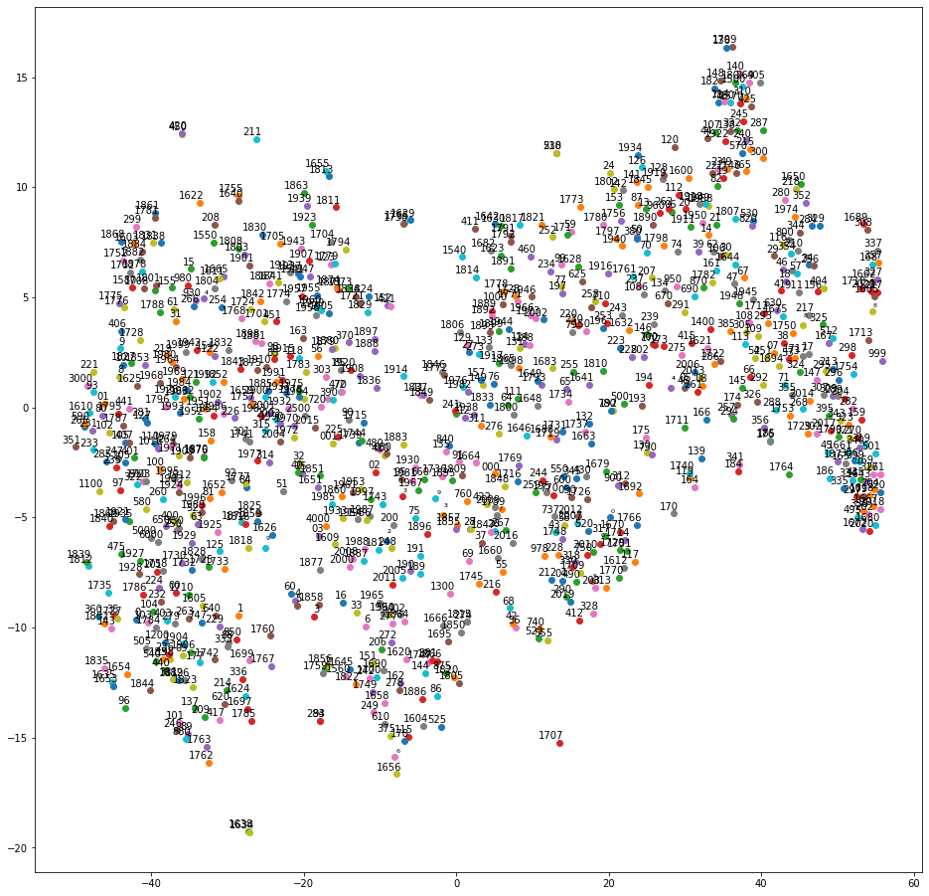

Figure 1. Relations between all numbers in BERT’s vocabulary. Each number is embedded in a 2-dimensional vector from its original 768-dimensional representation.

We can see that the space of numbers in BERT is nonlinear and isn’t ordered, that means BERT does not understand numbers and mathematical logic as we do.

The question that rises is: how close does BERT think the numbers are? Here are some comparisons between number similarity obtained with simple cosine similarity between embedding vectors.

|  |  |  |
| --- | --- | --- |
| First number | Second Number | Similarity score |
| 0 | 1 | 0.776 |
| 0 | 2 | 0.770 |
| 0 | 3 | 0.768 |
| 0 | 4 | 0.768 |
| 1 | 2 | 0.930 |
| 1 | 3 | 0.916 |
| 1 | 4 | 0.890 |
| 2 | 3 | 0.960 |
| 2 | 4 | 0.942 |
| 3 | 4 | 0.974 |

Here is also a list of some numbers in BERT’s vocabulary sorted by their similarity to 1: '1', '2', '282', '307', '333', '287', '327', '385', '417', '334', '245', '306', '285', …

This is just another proof that number-space in BERT is unordered.

*Results of comparing sentences that have similar or opposite meaning and contain numbers in them*

BERT is frequently used in analysing news, financial texts, etc. These texts contain a lot of numbers. Let’s see how BERT comperhands them (bert-base-uncased is used for this):

|  |  |  |
| --- | --- | --- |
| First sentence | Second sentence | Similarity |
| Apple stocks have increased in value by 1 percent | Apple stocks have dropped in value by 1 percent | 0.9857 |
| Apple stocks have increased in value by 1 percent | Apple stocks have increased in value by 000000001 percent | 0.9374 |

So, it finds sentences with opposite meaning closer that sentences with the same meaning because of different number representations.

The other thing that interested us in this experiment was to see how strongly does BERT associate numbers and words defining these numbers. Like 4-four, 5-five, etc. Here are some results:

|  |  |  |
| --- | --- | --- |
| 4 | four | 0.794 |
| 5 | five | 0.886 |
| 4 | 5 | 0.967 |
| four | five | 0.909 |

Clearly BERT does not associate digits and the words that represent them (we ran this test on a large amount of numbers, results were consistent)

Here are also some visualizations of heads of attention for sentences such as: Apple stocks have increased in value by 1 percent

and Apple stocks have increased in value by 000000001 percent



Figure 2. GIF representing the heads of attention for the sentence Apple stocks have increased in value by 1 percent



Figure 3. GIF representing the heads of attention for the sentence Apple stocks have increased in value by 000000001 percent

Here is a comparison of 11s layer of attentions, all heads between these 2 sentences:

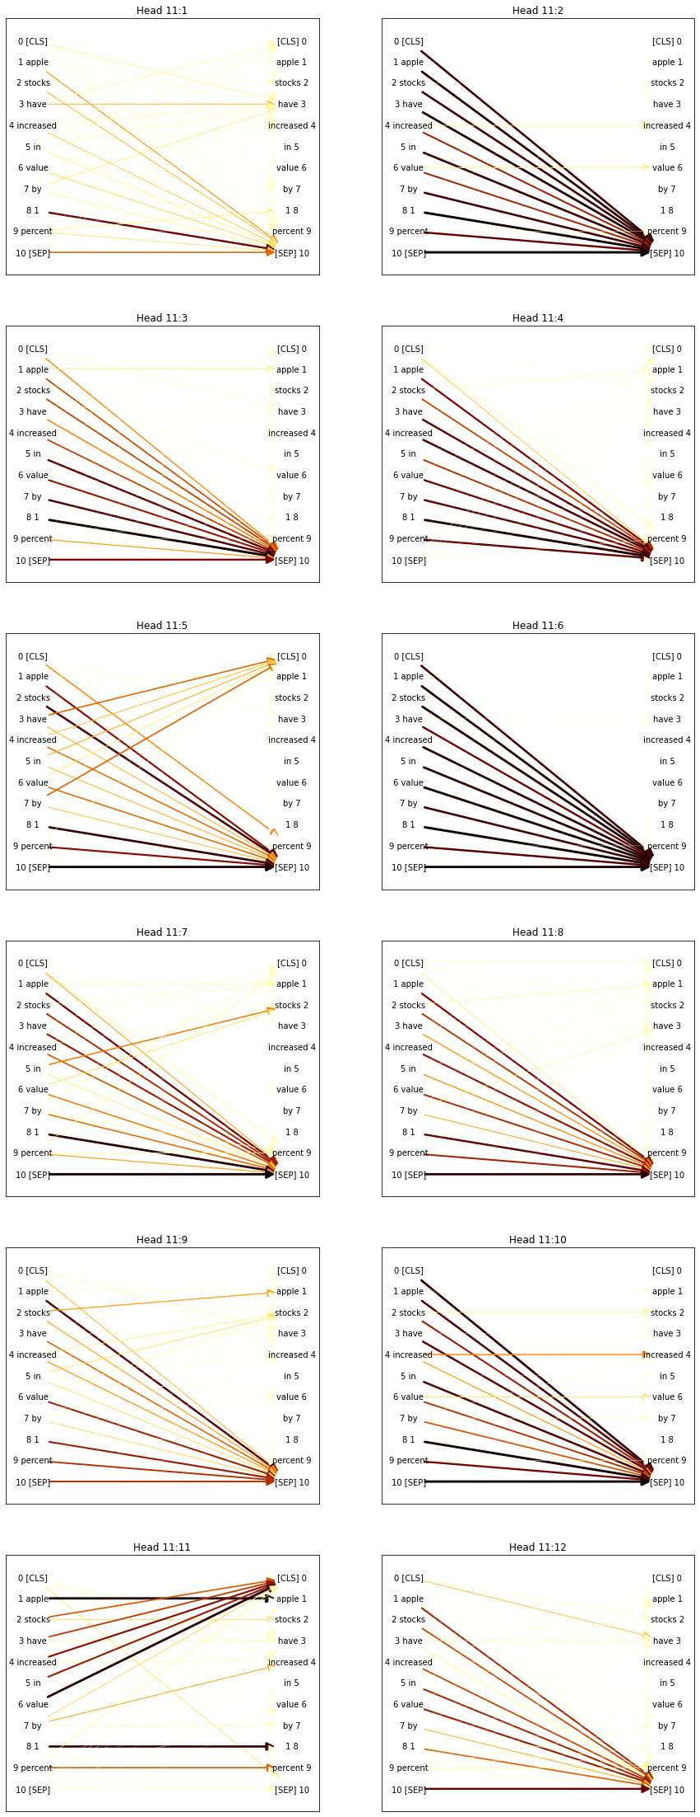

Figure 4. Heads of attention on layer 11 for the sentence Apple stocks have increased in value by 1 percent

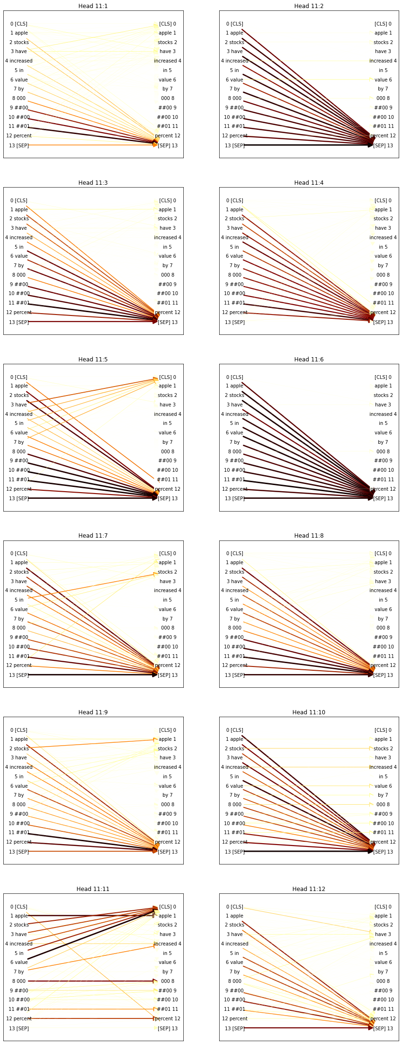

Figure 5. Heads of attention on layer 11 for the sentence Apple stocks have increased in value by 000000001 percent

*Question answering with BERT fine-tuned on SQUAD v1 testing on first grade level math problems.*

BERT can better answer the question if the actual answer is given in the context. Here are some examples of such questions with visualization of raw answer scores:

question = "How many buckets does the helper need?"

context = """9 and 10 are more than 8 and fewer than 11. The zoo got some new zebras.

The zookeeper asked the helper to deliver one bucket of food to each new zebra.The zookeeper gave his helper some clues about how many new zebras needed food.There are more than 8.There are fewer than 11.There are not 10."""

'score': 0.32921739525794436, 'start': 152, 'end': 155, 'answer': 'one'

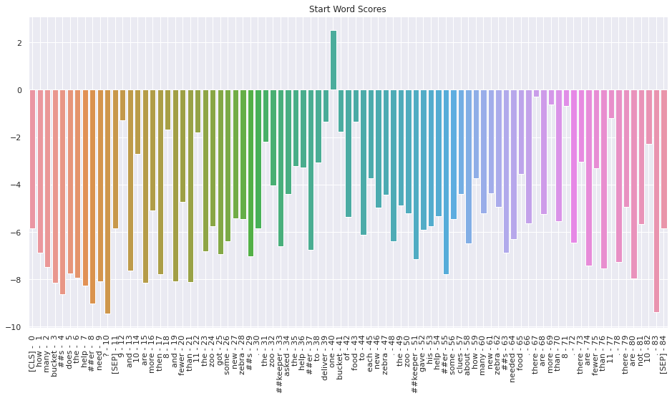

The certainty is low and the answer is incorrect. We also see that BERT really only considered one option - ‘one’.

The comparison between same question and different order of sentences in the context:

question = "How many bones did Spot hide?"

context = """Spot hid bones in the backyard. Johnny watched Spot hide the bones. Jenny wanted to know how many bones Spot hid. Johnny gave her some clues. There are more than 4. There are fewer than 7. There are not 5. 5 and 6 are fewer than 7 and more than 4."""

'score': 0.01485715104377097, 'start': 211, 'end': 225, 'answer': '4.'

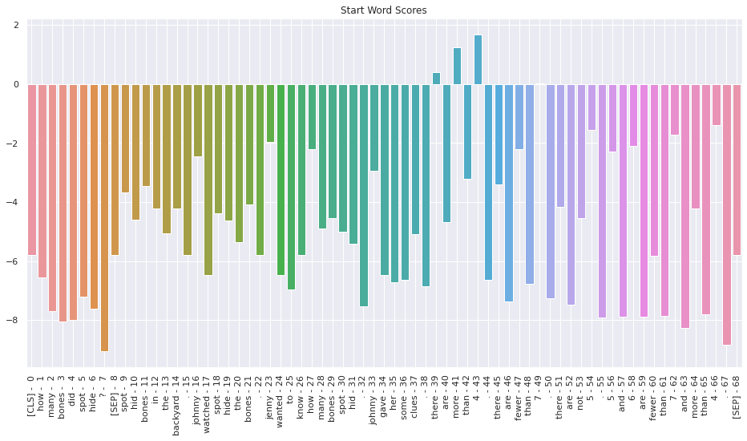

context = """Spot hid bones in the backyard. Johnny watched Spot hide the bones. Jenny wanted to know how many bones Spot hid. Johnny gave her some clues. There are fewer than 7. There are more than 4. There are not 5. 5 and 6 are fewer than 7 and more than 4."""

'score': 0.012212091066622025, 'start': 212, 'end': 226, 'answer': '7.'

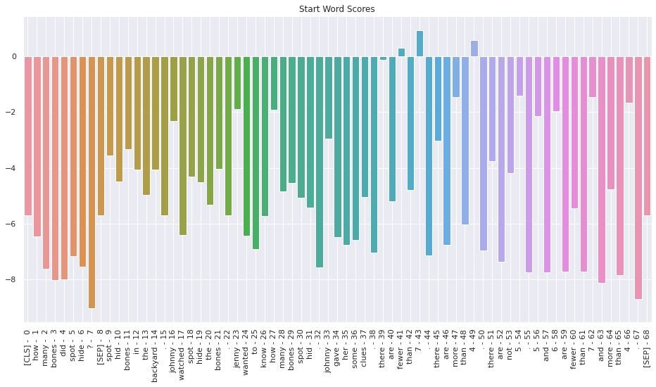

context = """Spot hid bones in the backyard. Johnny watched spot hide the bones. Jenny wanted to know how many bones Spot hid. Johnny gave her some clues. 5 and 6 are fewer than 7 and more than 4. There are fewer than 7. There are more than 4. There are not 5. """

'score': 0.0027135055432900845, 'start': 44, 'end': 121, 'answer': 'Johnny watched spot hide the bones. Jenny wanted to know how many'

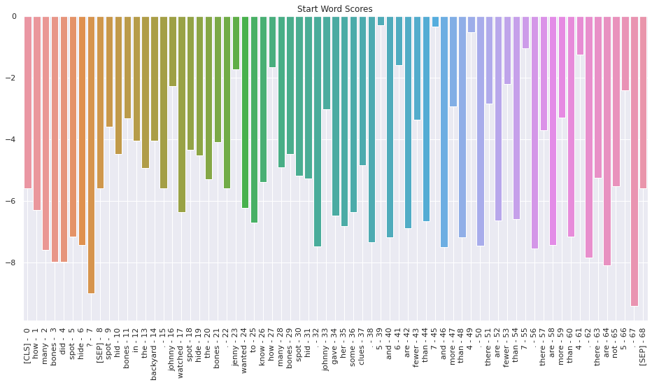

These problems turned out to be way too complex for BERT and it relied a lot on the position of the sentences in the context. Here are less complicated tasks:

question = "Who has more apples?"

context = """Polly has 5 apples. Eugene has 6 apples."""

'score': 0.8270043782307287, 'start': 21, 'end': 28, 'answer': 'Eugene'

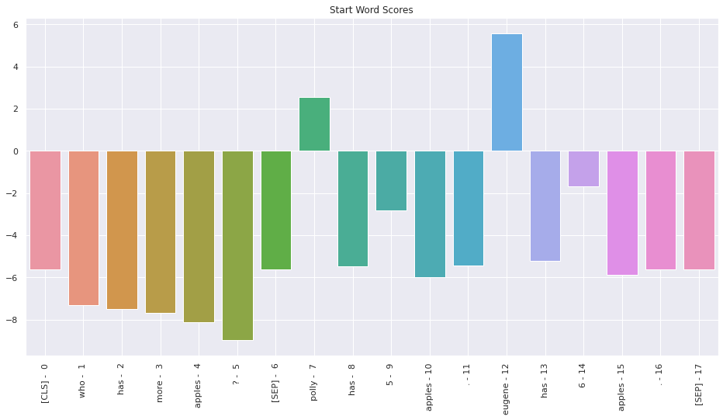

BERT answers correctly here. We conducted some more similar experiments changing the numbers and the question to see if the result will stay consistent:

question = "Who has more apples?"

context = """Polly has 134 apples. Eugene has 1 apple."""

Answer: eugene

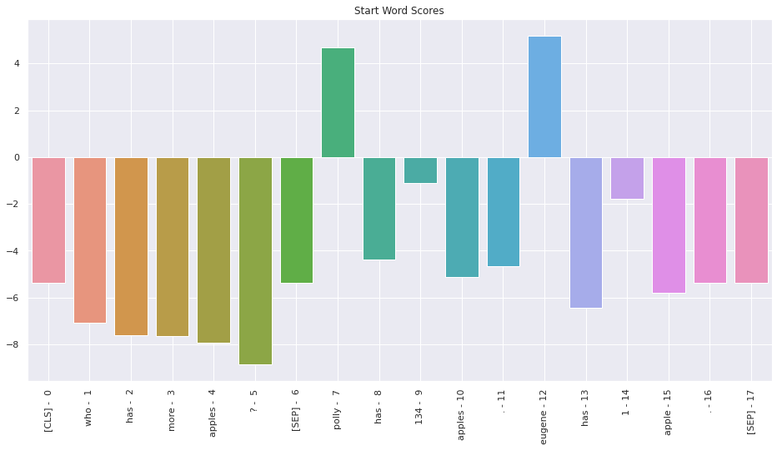

On different numbers the result is drastically different as we can see.

We changed the position of names to see if it plays any role:

question = "Who has more apples?"

context = """ Eugene has 6 apples. Polly has 1234 apples.

"""

Answer: polly

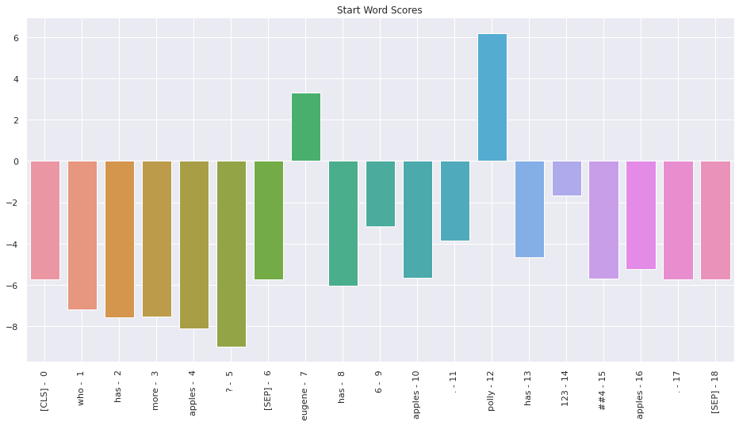

question = "Who has more apples?"

context = """ 7 apples is more than 1 apple. Polly has 7 apples. Eugene has 1 apple. """

Answer: polly

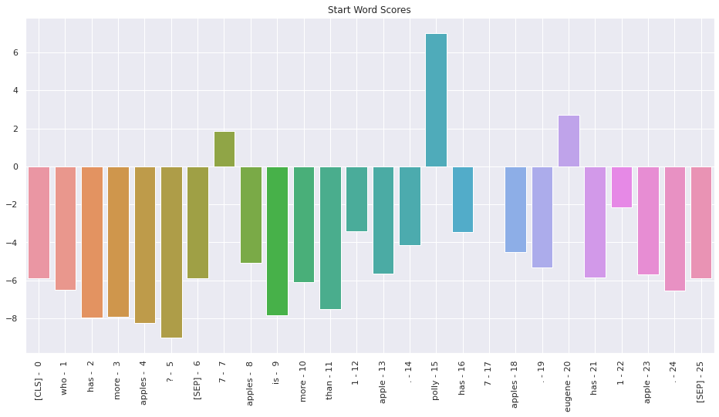

question = "Who has more apples?"

context = """ 7 apples is more than 1 apple. Polly has 1 apple. Eugene has 7 apples."""

Answer: eugene

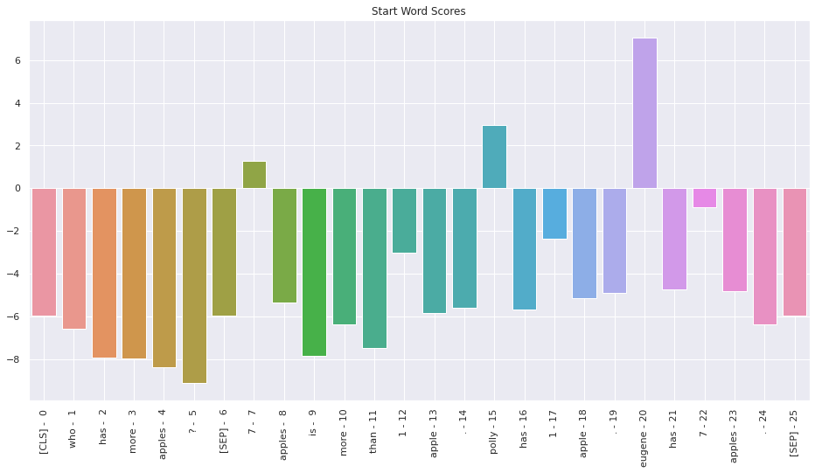

To make final experiments we created some code that generates a heatmap that shows results of different experiments with different names, numbers and questions like this:

score_matrix = np.zeros((100,100))

for i in range(100):

for j in range(100):

question = "Who has more shares?"

if i+j <=100:

context = """Polly holds {}% of shares. Eugene holds {}% of shares.""".format(i, j)

result = get_best_answer_score(question=question, answer_text=context, model=model, tokenizer=tokenizer)

answers_map = {'polly': 'eugene', 'eugene': 'polly'}

if i >= j:

correct_answer = 'polly'

else:

correct_answer = 'eugene'

if correct_answer in result["answer"]:

score_matrix[i,j] = result["score"]

elif answers_map[correct_answer] in result["answer"]:

score_matrix[i,j] = - result["score"]

else:

score_matrix[i,j] = None

print(score_matrix[i])

plt.imshow(score_matrix, cmap='Blues')

Results were somewhat surprising:

Question - Who holds more shares?

Problem - “Polly holds n % of shares. Eugene holds m % of shares.”

Answers:

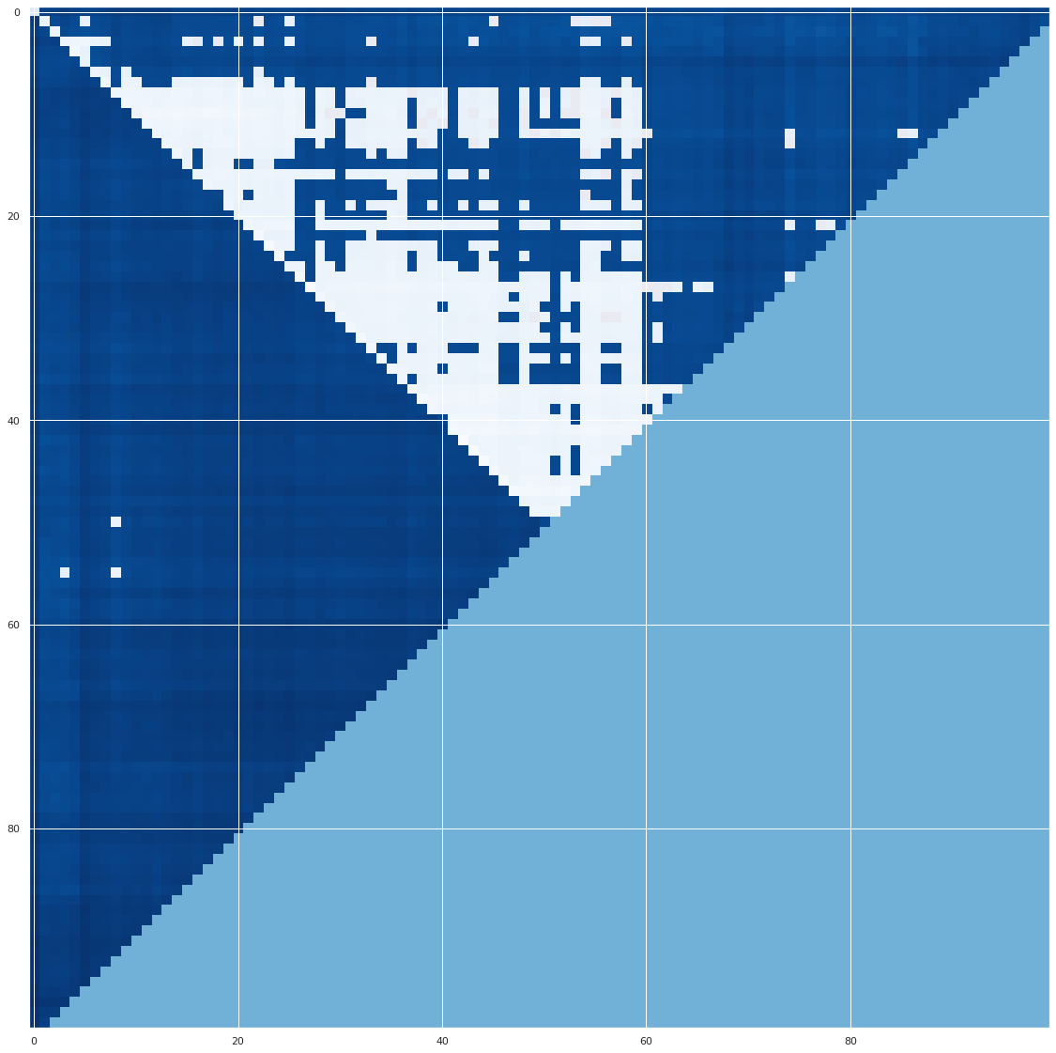

In this set of experiments BERT was more likely to answer incorrectly that Polly has more shares if n<m and ~ 7<n<50 & 7<m<60. Overall it tends to answer “Polly”. Almost no mistakes were made when the correct answer was “Polly”.

Next, we did the same set of experiments, but the question was “Who has less shares?” Here are the results:

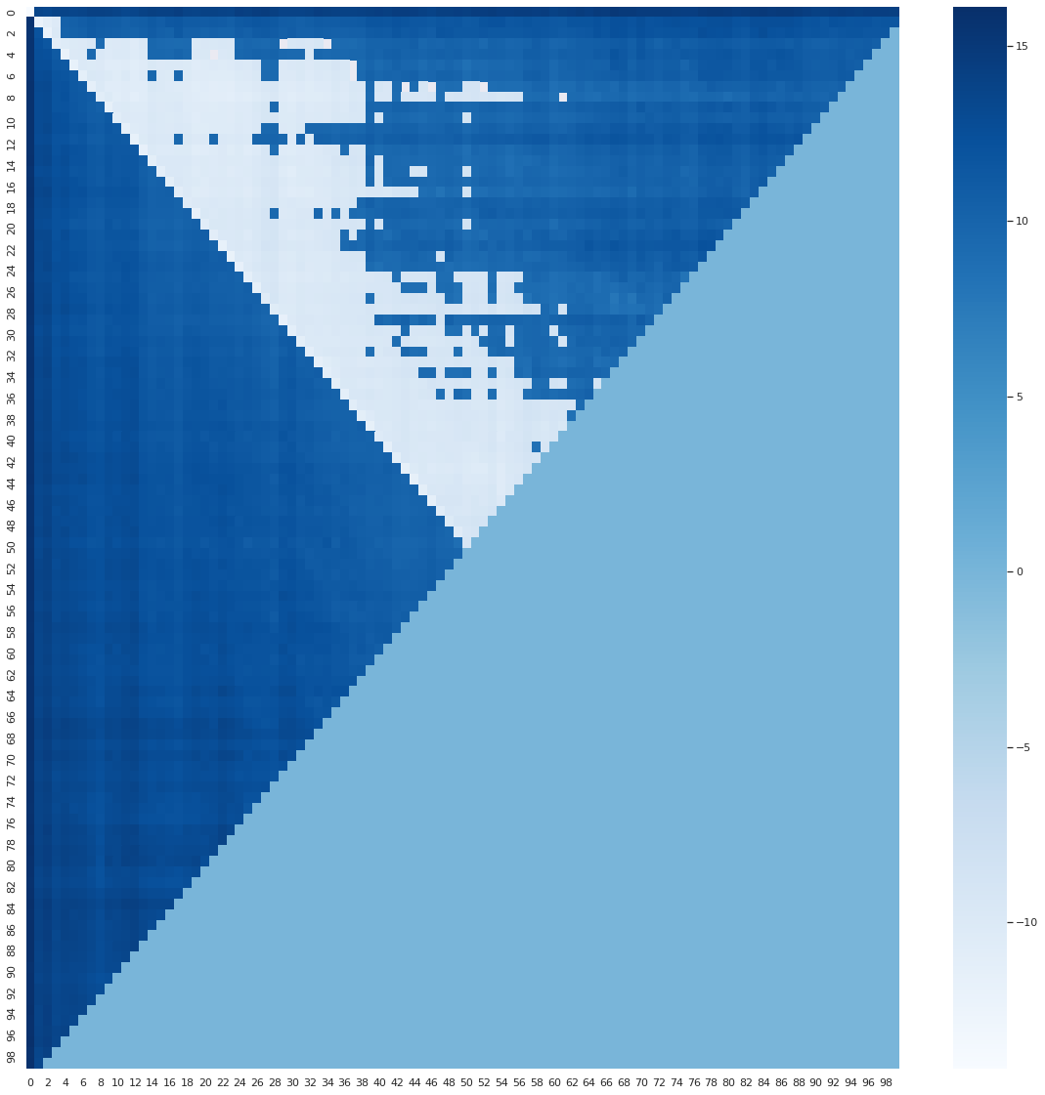

Now, the result changed and BERT answered “Eugene” more frequently, within the same ranges of n and m as in the previous result.

Very surprising was that when we actually switched the names:

Question - Who holds more shares?

Problem - “Eugene holds n % of shares. Polly holds m % of shares.”

BERT made almost no mistakes!

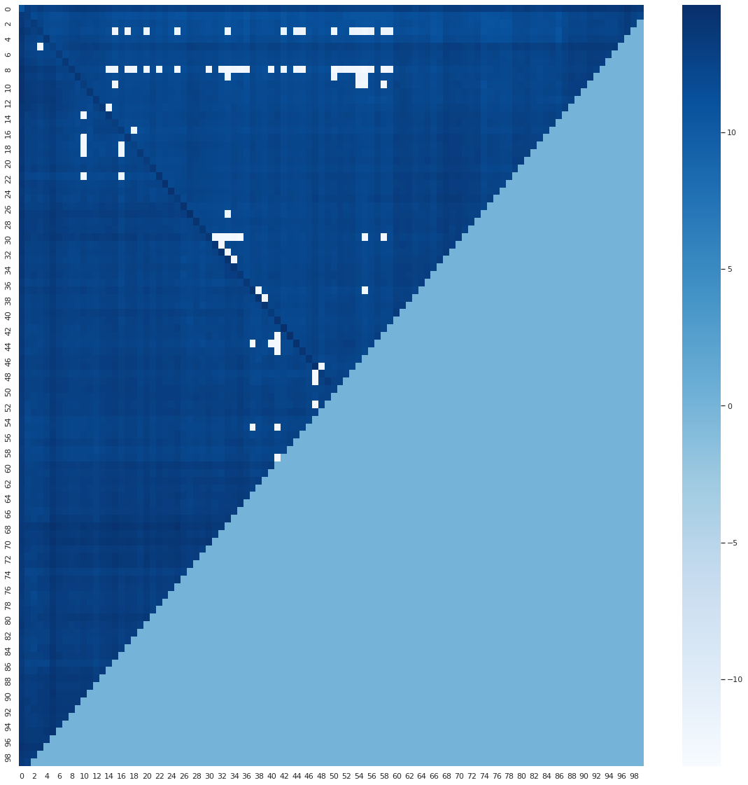

Than we switched the names to a different pair of male and female name, placing the male name in the first sentence and the female in the second:

Question - Who holds more shares?

Problem - “John holds n % of shares. Maria holds m % of shares.”

And got results similar to the Eugene-Polly sentence:

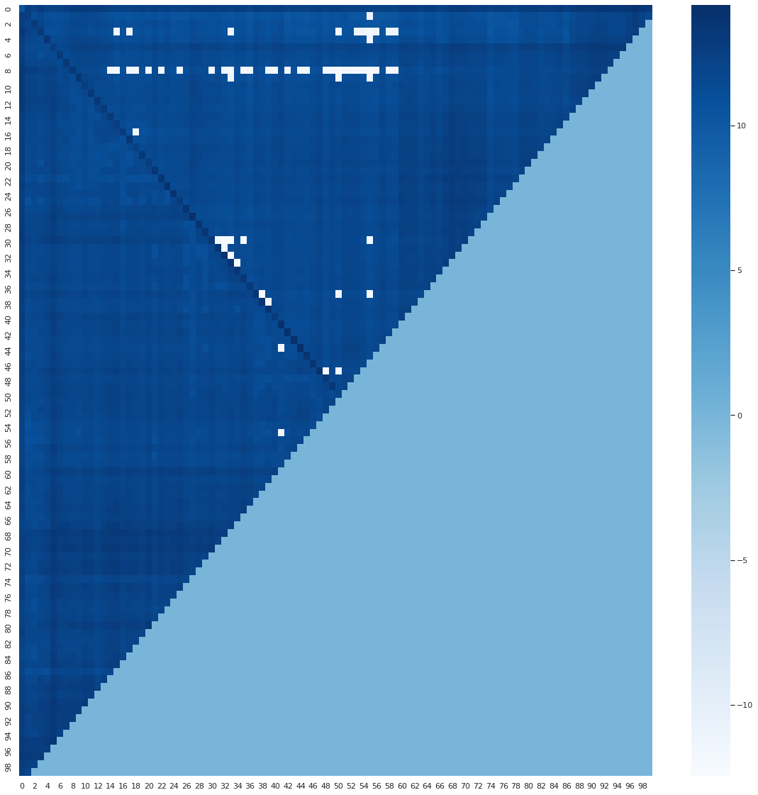

When the female name was in the first sentence again we see one of the worst results so far:

Question - Who holds more shares?

Problem - “Maria holds m % of shares. John holds n % of shares.”

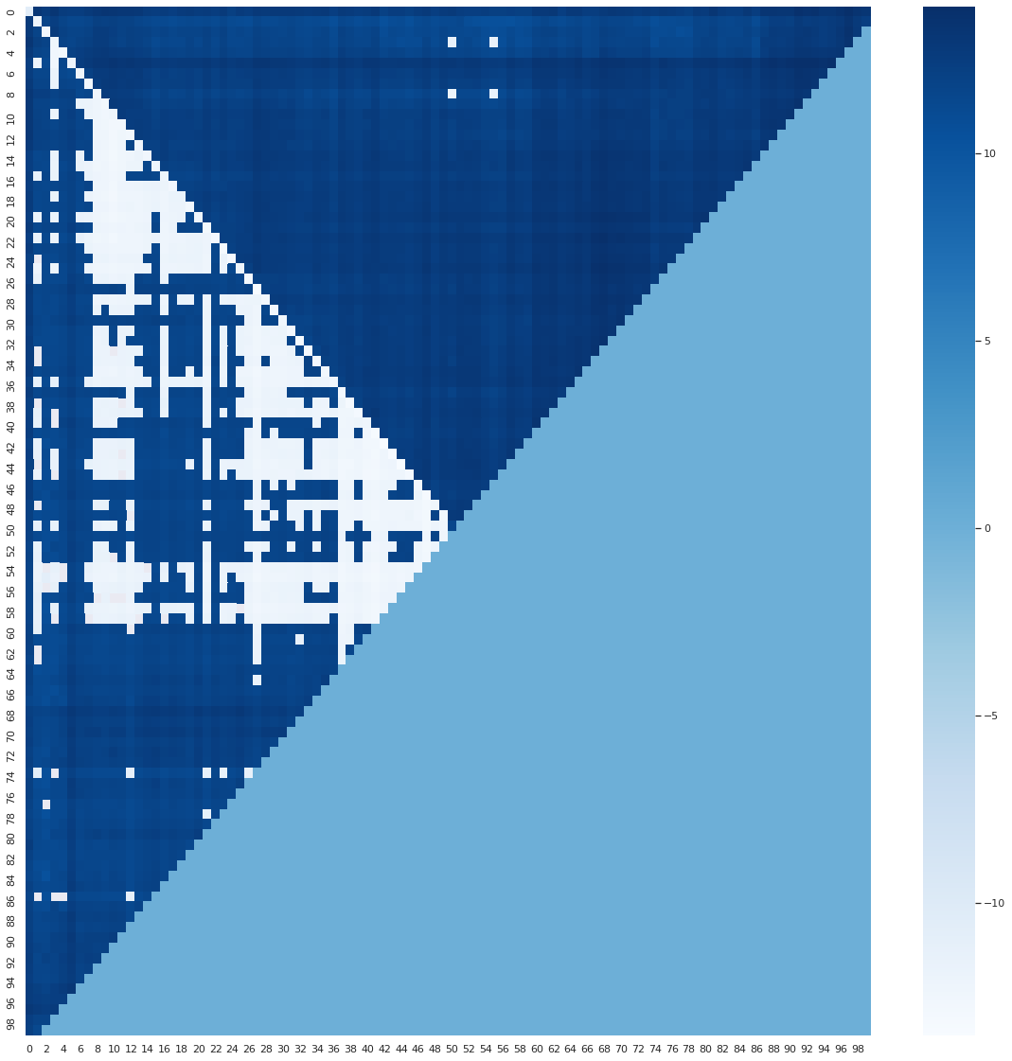

BERT answered “Maria” more frequently. The distribution of answers is similar to the first experiments.

For the last experiment we compared not numbers from 0 to 100, but from a range like from 181734672 to 181734772. These numbers are not in vocabulary and BERT essentially has no idea how to compare them.

Question - Who holds more shares?

Problem - “Eugene holds n % of shares. Polly holds m % of shares.”

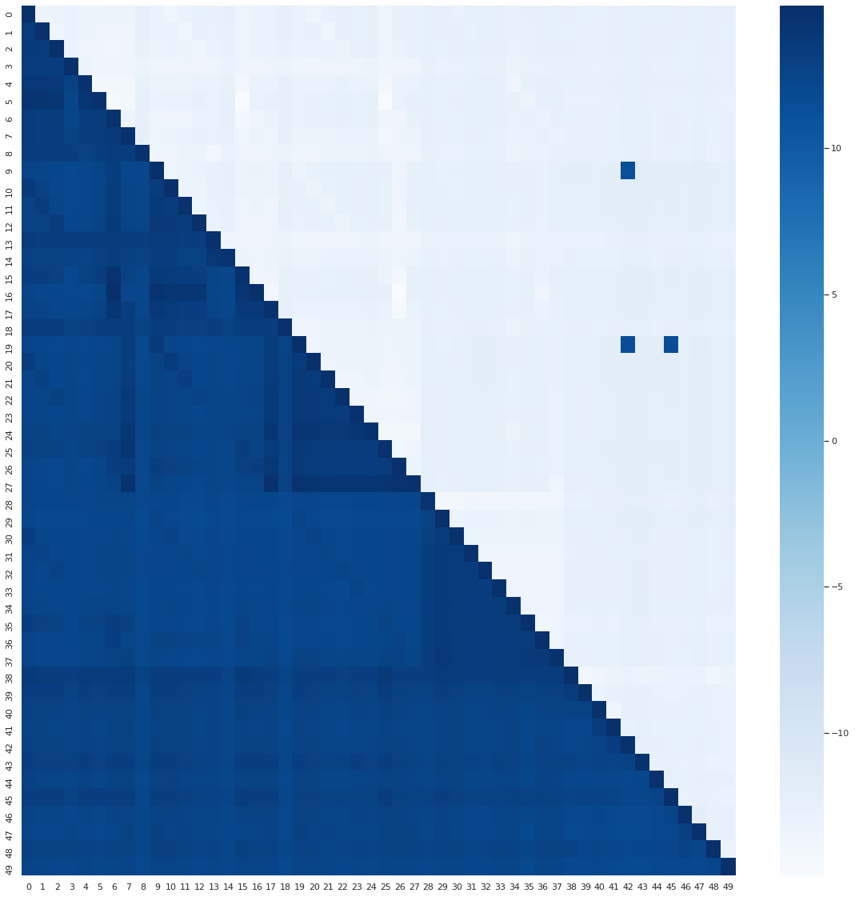

(Eugene has more in the top half and less in the bottom half)

In this case BERT just always answered “Polly”.

# Conclusion

The results clearly show that BERT does not understand numbers in a way we do. It cannot reason mathematically and will rely on other factors such as names, genders, position of the words around numbers in mathematical problems more than on numbers themselves. BERT appears to have a bayes for male and female names and order in which they appear. While it is able to comprehend some small numbers sometimes, numbers that are more than 5 digits are never comprehended correctly. We would not recommend using such models to comprehend texts that have their core value represented in numerical data. These texts include statistics, financial data, scientific texts, etc.

# Further Research

*Exploring relations between numbers in BERT’s vocabulary.*

BERT has not only numbers that consist of digits in its vocabulary. It also has word representations of numbers, like: one, two, three, etc. Further experiments may show the relations between word representations of numbers and how they correlate with digital numbers in vocabulary.

Also, we encourage you to dive deeper into number comparisons as done in the last section of the experiments and explore more pypes of mathematical problems with different names and entities.

# 

